



Table of Contents

**1. Introduction 2**

**1.1 Background and Motivation 2**

1.1.1 Background 2

1.1.2 Motivation 3

**1.2 Visualisation purpose 3**

**1.3 Project Schedule 3**

**2. Data 4**

2.1 Data Source 4

2.1.1 Data Source 1: Estimated number of Australian resident born overseas by country of birth 4

2.1.2 Data Source 2: Net overseas migration by major groupings and visa 5

2.1.3 Data Source 3: 6

2.2 Data Processing 6

**Requirement 7**

3.1 Must Have features 7

3.2 Optional Features 8

**Visualisation Design 8**

4.1 8

4.2 9

**Validation 9**

**Conclusion 10**

**References 11**

# **Introduction**

## **1.1 Background and Motivation**

### **1.1.1 Background**

Migration is the movement of people from one area to another for a number of reasons. The reasons for this might be related to economic, social, environmental, or political factors. The phenomenon of migration is complicated and ever-changing, with significant social, economic, and political consequences. This is crucial for academics, researchers, government officials, and humanitarian organisations who are working in this sector to understand the migration pattern and trends. As non-experts consider it challenging to understand and analyse migration statistics data, it is crucial that a visualisation be created.

There are two types of migration which are internal migration and international migration. According to Amruta, P. (2023), Internal migration refers to the movement of people inside the countries, and international migration refers to the movement of people from one country to another country in order to gain a better living conditions. One of the measurements of migration is the net migration rate. According to the Central Intelligence Agency(n.d.), the Net migration rate refers to the difference between the total number of people coming into and departing a country throughout the year per 1,000 people based on the midyear rate.

The reasons for people to migrate vary. One of the factors that contribute to the migration of people is Overseas birth. Overseas birth is considered birth tourism. According to Kiwimedi Support (2022), overseas birth refers to the practice of travelling abroad to another country to give birth. An overseas birth allows the child to obtain citizenship in the country of birth.

As a result of producing a visualisation related to migration patterns and trends, it can assist in providing non-experts with a more simple and engaging representation of migration data. In addition, it can provide further analysis regarding patterns and trends that are not immediately noticeable from a table format.

**1.1.2 Primary objectives of the Visualisation**

The primary objective of the visualisation website of our visualisation shows the following data:

* The estimated population of migrants living in Australia
* The net internal migration of each state in Australia
* The net overseas migration in Australia

## **1.2 Visualisation purpose**

Researchers, social organisations, and officials working in the migration sector may find the visualisation helpful in answering the following questions:

1. Which types of Australian Visa have the most significant overseas arrivals?
2. Why do migrants move to Australia?
3. Where do most migrants in Australia come from?
4. Which states in Australia have the most significant internal migration?

## 

## 

## 

## 

## 

## 

## 

## 

## 

## **1.3 Project Schedule**

|  |  |  |
| --- | --- | --- |
| **Task No.** | **Task explanation** | **Date** |
| 1 | Set up Github repository and google drive | 28/03/2023 |
| 2 | Research about what migrations topics want to be visualised in the website | 29/03/2023 |
| 3 | Identify questions that need to be answered in the website visualisation | 03/04/2023- 07/04/2023 |
| 3 | Find datasets that relate to the project questions. | 10/04/2023-17/04/2023 |
| 4 | Process and Transform the datasets into the desired data | 17/04/2023 - 23/04/2023 |
| 5 | Brainstorm different types of visualisation that can be considered to use in every three visualisations | 24/04/2023 - 05/05/2023 |
| 6 | Sketch the visualisation iterations | 24/04/2023- 07/05/2023 |
| 7 | Identify the visualisation design principle which needs to be applied in the three visualisations | 01/05/2023 - 10/05/2023 |
| 8 | Start doing the website coding | 01/05/2023 |
| 9 | Coding 1.1: Create navigation menu bar and footer for the website using HTML and CSS | 01/05/2023 |
| 10 | Coding 1.2: Create a home page of the website using HTML and CSS. This includes an explanation of what the website is used for. | 02/05/2023 |
| 11 | Coding 1.2: Create first visualisation in d3.js | 10/05/2023 |
| 12 | Coding 1.3: Create second visualisation in d3.js | 16/05/2023 |
| 13 | Coding 1.4: Create third visualisation in d3.js | 20/05/2023 |
| 14 | Finalising the website coding | 27/05/2023 |
| 15 | Create an informed consent form in google | 23/05/2023 |
| 16 | Create a questionnaire to be answered by the user in usability testing | 24/05/2023 |
| 17 | Do usability testing with users | 28/05/2023 - 01/06/2023 |
| 18 | Make a report from the usability testing result | 01/06/2023 |
| 19 | Fix the website according to the user's input or recommendation | 01/06/2023 |
| 20 | Finalise design process book | 03/06/2023 |
| 21 | Finalise the website | 03/06/2023 |

# 

# 

# 

# 

# 

# **2. Data**

## **2.1 Data Source (Proposal)**

### **2.1.1 Data Source 1: Estimated resident population in Australia by**

### **country of birth**

The first source dataset shown in Figure 1 represents the estimated population of residents by country of birth in Australia during a 20-year period, from 1996 to 2016.

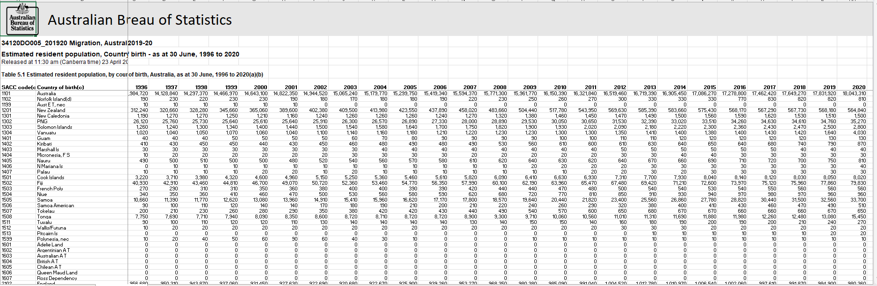

**Figure 1: First source dataset**

The data in the first source dataset was gathered by the Australia Bureau of Statistics for their website abs.gov.au. The data used in the visualisation is free and used without endorsement.

The data from abs.gov.au is in a tabular format which consists of the following attributes:

|  |  |  |  |
| --- | --- | --- | --- |
| Attributes No. | Attributes | Description | Types |
| 1 | SACC Code(a) | This field contains the SACC codes for each country. SACC codes refer to the codes which classify the countries based on the geography proximity concept. | Nominal(categorical) data |
| 2 | Country of Birth | This field indicates the origin country of migrants living in Australia | Nominal(categorical)data |
| 3 | Years: 1996 - 2019 | The estimated number of residents by country for each year is provided in this field | Numerical(Ratio) data |

Table 1: Data Types, attributes, and description of Data Source 1

* **Dataset source link:** <https://www.abs.gov.au/statistics/people/population/australias-population-country-birth/latest-release> (need to be a reference)

### **2.1.2 Data Source 2: Regional Internal Migration provisional, March 2021**

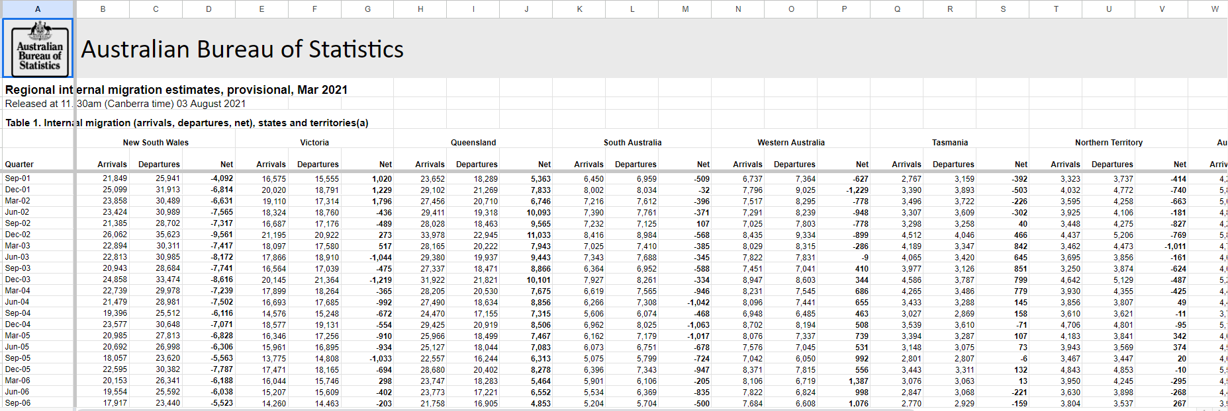The second source dataset that will be used in this visualization consists of the estimated regional internal migration in different states of Australia in the year of 2021 as shown in Figure<> .This second source dataset will be used and processed to provide a visual representation of which states have a high level of internal migration, as measured by the Net Internal Migration coefficient. The data was gathered by the Australia Bureau of Statistics for their website abs.gov.au. The data used in the visualisation is free and used without endorsement.

The data from abs.gov.au is in a tabular format which consists of the following attributes:

|  |  |  |  |
| --- | --- | --- | --- |
| Attributes No. | Attributes | Description | Types |
| 1 | Quarter | This field specifies the date when the number of migrants arriving and departing from a particular state are estimated. | Nominal(categorical)data |
| 2 | States:  New South Wales,  Victoria, Queensland,  South Australia, Western Australia, Tasmania, Northern Territory, Australian Capital Territory | This field specifies the name of states in Australia. This field contains subfields which are arrival, departure, and Net. | Nominal(categorical) data |
| 3 | Arrivals | This field specifies the estimated number of migrants arriving at a particular state | Numerical(discrete) data |
| 4 | Departure | This field specifies the estimated number of migrants departing from a particular state. | Numerical(discrete) data |
| 5 | Net | This field specifies the difference between the number of migrants arriving and departing from a particular state. | Numerical(ratio) data |

* **Dataset source link:** [**https://www.abs.gov.au/statistics/people/population/migration-australia/latest-release#net-overseas-migration**](https://www.abs.gov.au/statistics/people/population/migration-australia/latest-release#net-overseas-migration)

### **2.1.3 Data Source 3:**

The third source dataset consists of the Net Overseas Migration between different states in Australia as shown in Figure<>. The third source dataset can provide an insight into the motivations of the migrants to migrate to Australia. ABS (2021) stated that by analysing migrants across major groups and visa categories, users would be able to gain a deeper understanding of the factors that influenced migrants' migration to Australia. The third source data was gathered by the Australia Bureau of Statistics for their website abs.gov.au. The data used in the visualisation is free and used without endorsement.

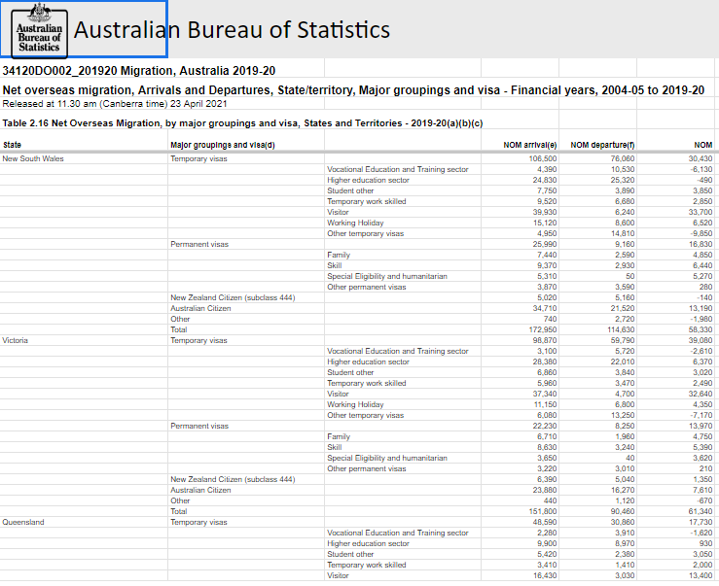

The data from abs.gov.au is in a tabular format which consists of the following attributes:

|  |  |  |  |
| --- | --- | --- | --- |
| Attributes No. | Attributes | Description | Types |
| 1 | States | This field provided all the state names in Australia. | Nominal(categorical) data |
| 2 | Major grouping and visas | This field give information about the types of visa which is available to be used by migrants in Australia | Nominal(categorical)data |
| 3 | NOM arrivals | This field gives information about the estimated number of people who arrive in Australia. | Numerical (Ratio) data |
| 4 | NOM departure | This field gives information about the estimated number of people who depart from Australia. | Numerical (Ratio) data |
| 5 | NOM | This field give the difference between the estimated number of people arriving in Australia and departing from Australia | Numerical(ratio) data |

## **2.2 Data Processing**

### **2.2.1 Dataset 1 Data Processing and Transformation**

The first source data was processed and cleaned using a processing technology known as Knime Analytics platform. Knime analytics platform is open source which allows users to blend, process data and do analysis of the data without the use of coding(ref). The data processing and transformation steps are listed below:

1. We begin by removing any labels that are not contained within the table. The labels containing the Australia Bureau of Statistics logo, the release date of the dataset, the file name of the source dataset, and the name of the table were removed as shown in Figure 1. 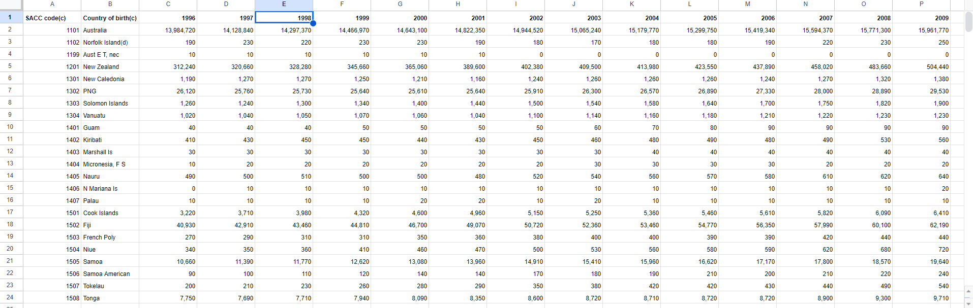

**Figure 1: First source datasets without the unnecessary labels**

1. The next step we did was to upload the source dataset into a data processing technology known as Knime Analytic platform. Knime analytics platform is open-source which allows users to blend, process data and do analysis of the data without the use of coding. The source dataset is uploaded into a file reader node where this node will read the source data set CSV file.
2. We use Knime analytics platform’s column filter node to filter the SACC codes and the year of 1996 to 2019 attributes as shown in Figure 2. The year of 1996 to 2019 attributes were removed as the visualisation will focus more on the estimated resident population by country of birth in the year of 2020. After we filtered the unnecessary attributes, we used column rename nodes to rename our attributes. The 2020 attributes were modified into “Estimated Resident Population” as shown in Figure 3.

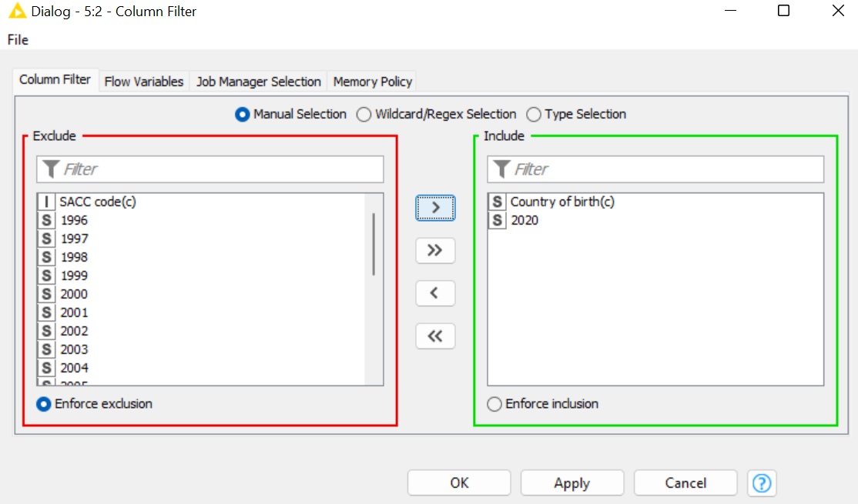

**Figure 2 : Column filter node configuration**

**Figure 3: Column rename node configuration**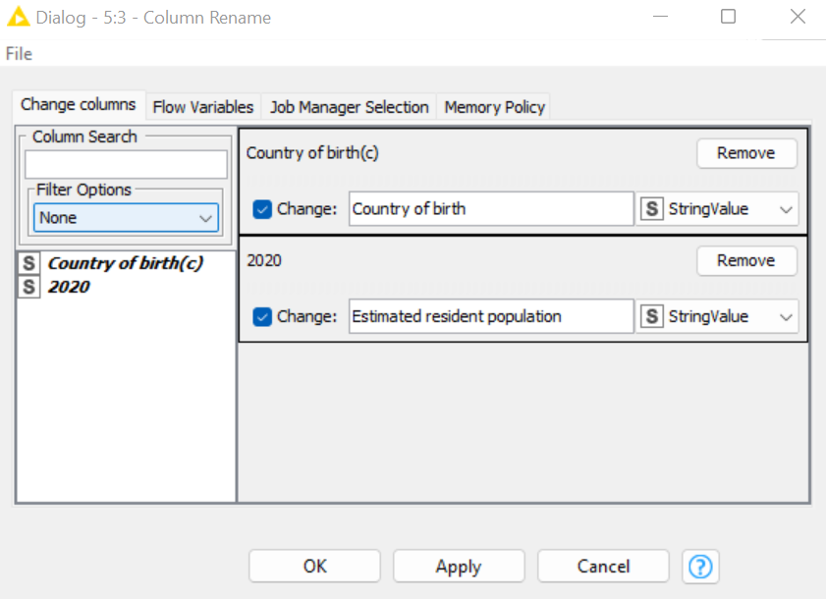

1. After renaming the attributes, we connect the column rename node into a rule-based row filtering node to filter out rows with 0 values. This is done by configuring an expression of “$Estimated resident population$ = 0 => TRUE” in the rule-based row filter as shown in Figure 4.

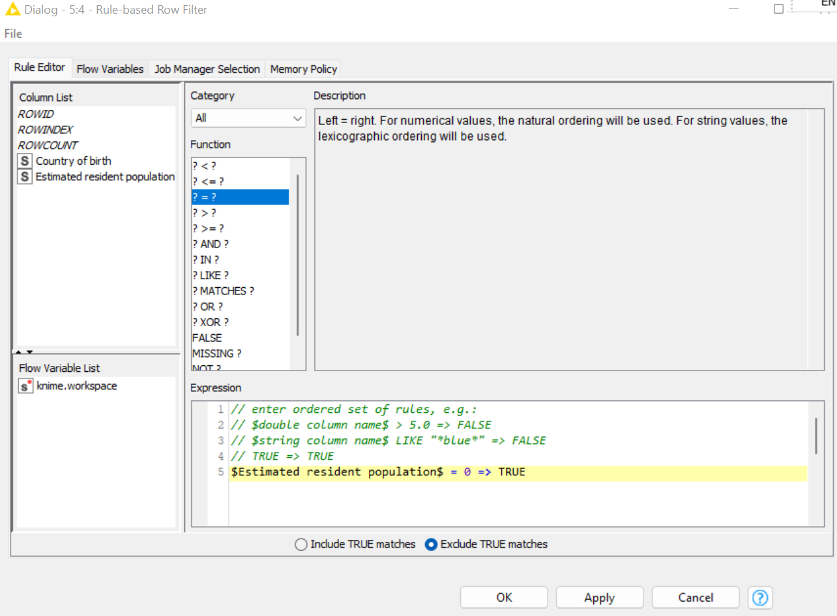

**Figure 4: Rule based row filter(Step 4) node configuration**

1. The next step is to remove any commas that are present in every row. This is done by connecting the row filter node into a string manipulation and configuring an expression of “replace ($Estimated resident population$,",”, "")”. This action is done to ensure all the estimated resident population data has the same data format.
2. To make the datasets smaller, we only take countries that have a population of more than 100,000 as the visualisation goal is to know where migrants mostly come from, and this can be seen from the country that has the most estimated resident population in Australia. This is done by using a rule row-based filter node in Knime where expressions of “$Estimated resident population$ < 100000 => TRUE $Country of birth$ = "Australia" => TRUE” were configured. This expression was used to remove any rows that have an estimated resident population less than 100,000 and remove Australia row from country of birth attributes. The rule-based row filter results are shown in Figure 5.

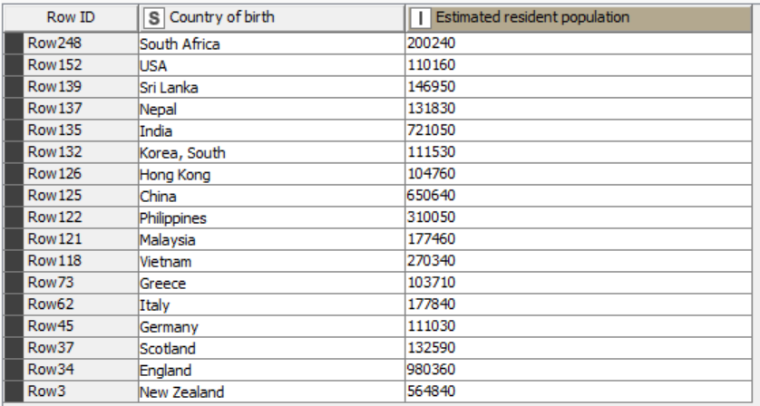

**Figure 5: Rule-based row filter (step 6) result**

1. As the results were not in order, we connected it to a sorter node which sorted the result of estimated resident population in descending order as shown in Figure 6.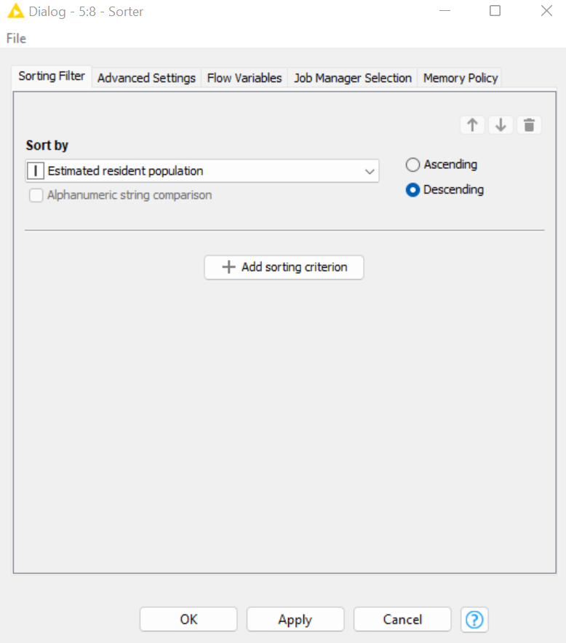

**Figure 6: Sorter node configuration**

1. The final step is to place the sorter result into a new CSV file which this was done by connecting the sorter node into a CSV writer node. The final CSV data file is shown in Figure 7.

### **2.2.2 Dataset 2 Data Processing and Transformation**

The second source dataset is processed using the basic Excel function.

1. We begin by removing any labels that are not contained within the table. The labels containing the Australia Bureau of Statistics logo, the release date of the dataset, the file name of the source dataset, and the name of the table were removed as shown in Figure 7.
2. The second step is to retrieve the New South Wales, Victoria, Queensland, South Australia, Western Australia, Tasmania, Northern Territory and Australian Capital Territory from the source datasets and place these into a new Excel workbook as shown in Figure 8.
3. Second, we sum up the total arrival, departure and net internal migration of each state using the Excel formula of sum. The excel formula is “=sum (First row : last row)”
4. Third, we place the total arrival, departure, and net internal migration into a different Excel workbook. In the new Excel workbook, we make unique attributes of total estimated arrivals, total estimated departures, and the total net internal migration, which is shown in Figure 9.

### 

### **2.2.3 Dataset 3 Data Processing and Transformation**

1. First, we retrieve the Australia state sections from Net overseas migration by major groupings and visa-2019-20 table and place it in a new excel sheet as shown in Figure<>.
2. After placing it in a new excel sheet we remove the non-related attributes such as NOM departure and NOM as the visualisation will focus on the migrants that come to Australia in the year of 2019-2020. We want to focus on the two types of visa groups which are permanent visa and temporary visa.
3. After we remove the non-related attributes, we remove the New Zealand Citizen (subclass 444), Australia Citizen, other, and total rows as shown in Figure <>.
4. After removing the rows that are not necessary, we split the temporary visa and permanent visa section into 2 excel sheets as shown in figure<>.
5. In the new excel sheets, we rename the attributes. For the temporary visa section, we rename the temporary visa attributes into “Types of temporary visa”. In the permanent visa section, we rename the permanent visas attributes into “Types of permanent visa”. These are shown in Figure <>.

## **2.3 Final data sets**

**2.3.1 First final dataset: Estimated resident population in Australia by country of birth (2020)**

In the first visualisation, the first final dataset was used to convey a message about the country that most immigrants to Australia hail from. A measure of this can be found in the estimated resident population value. The first final dataset has two attributes, namely the country of birth and the estimated resident population values shown in Figure <>.

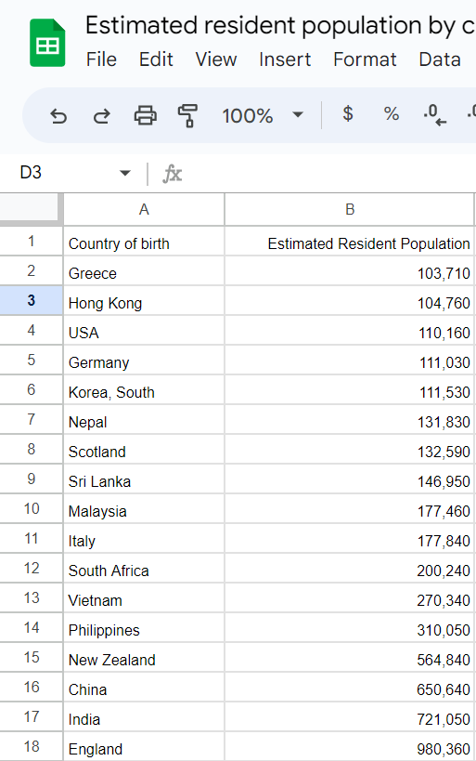

**2.3.2 Second final dataset: Internal migration in Australia (2021)**

In the second visualisation, the second final dataset was used to convey a message about the state in Australia that has the most internal migration. A measure of this can be found in the total net migration, total estimated arrivals, and total estimated departure. The second final dataset has four attributes, namely the states, total estimated arrivals, total estimated departure, and total net migration as shown in figure <>.

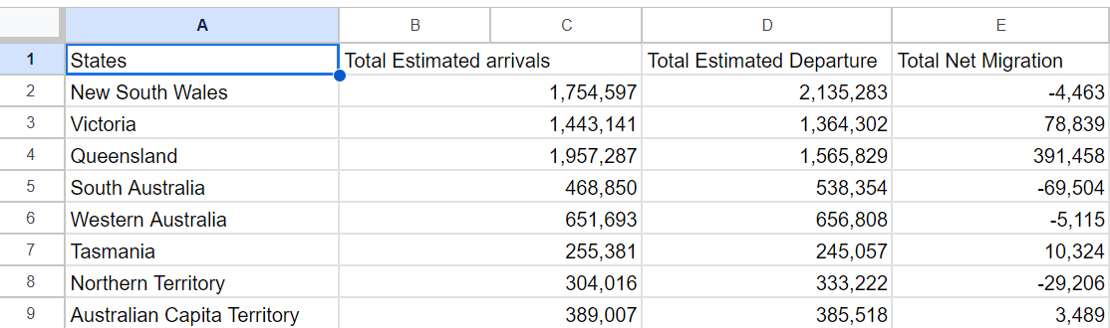

**2.3.3 Third final datasets: Net overseas migration arrivals in Australia per temporary visa**

In the third visualisation, the third final dataset was used to convey a message about the visa majority used by migrants to come to Australia. This dataset can also be used to analyse the motivation and the pathway for people to migrate to Australia. A measure of this can be found in the net overseas migration arrivals in each temporary visa categories. The third final dataset has two attributes, namely the types of temporary visa and NOM arrivals as shown in figure <>.

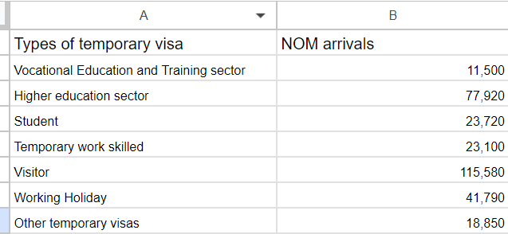

**2.3.4 Fourth final datasets: Net overseas migration arrivals in Australia per permanent visa**

In the third visualisation, the fourth final dataset was used to convey a message about the visa majority used by migrants to come to Australia and it is also used to provide an analysis to user about the motivation and the pathway for people to migrate to Australia. A measure of this can be found in the net overseas migration arrivals in each permanent visa categories. The fourth final dataset has two attributes, namely the types of permanent visa and NOM arrivals as shown in figure <>.

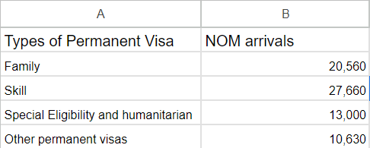

# 

# 

# **3. Requirement**

## **3.1 Must-Have Features**

### **3.1.1 Proposal Features**

1. Title

The title needs to be given for the researchers to understand the context and the information that want to be conveyed by the visualisation.

1. Axes and scales

An X and Y scale should be included in all visualisations that define independent and dependent variables. Marks on the axes are used to indicate the unit of measurement.

1. Axes label

The axes should be labelled so that the user can determine what information is represented by each axis.

1. Legend and Legend Key

The legend and legend key should be included in the visualisation to assist users in understanding the data contained in the visualisation as well as to assist them in understanding the message intended by the visualisation.

1. Colour

In the visualisation, distinct hues should be used to represent different categories. This will allow users to compare a wide range of categories and distinguish between them easily. The use of different saturation colours in the image is necessary to convey numerical values, such as choropleth and heat map. Various values are represented in the illustration using saturation colours. The use of colours is useful for attracting users by making the visualisation more appealing and engaging the audience in viewing it.

1. Brief Explanation

The user should be provided with a brief explanation in the website of how to use the visualisation and how to access the data found within it.

## 

## **3.2 Optional Features**

1. Interactive Features

The interactive features that must be included on the website are:

* Mouse over text effect
* Buttons
* Animation and transition of graph

1. The website shall be easily used and explored by non-technical users.
2. The website visualisation shall be able to convey the visualisation message to users.

# **Visualisation Design**

## **4.1 Visualisation Design (Proposal)**

## **Visualisation 1: Estimated Resident Population in Australia**

* 1. **Option 1: Horizontal Bar Graph**

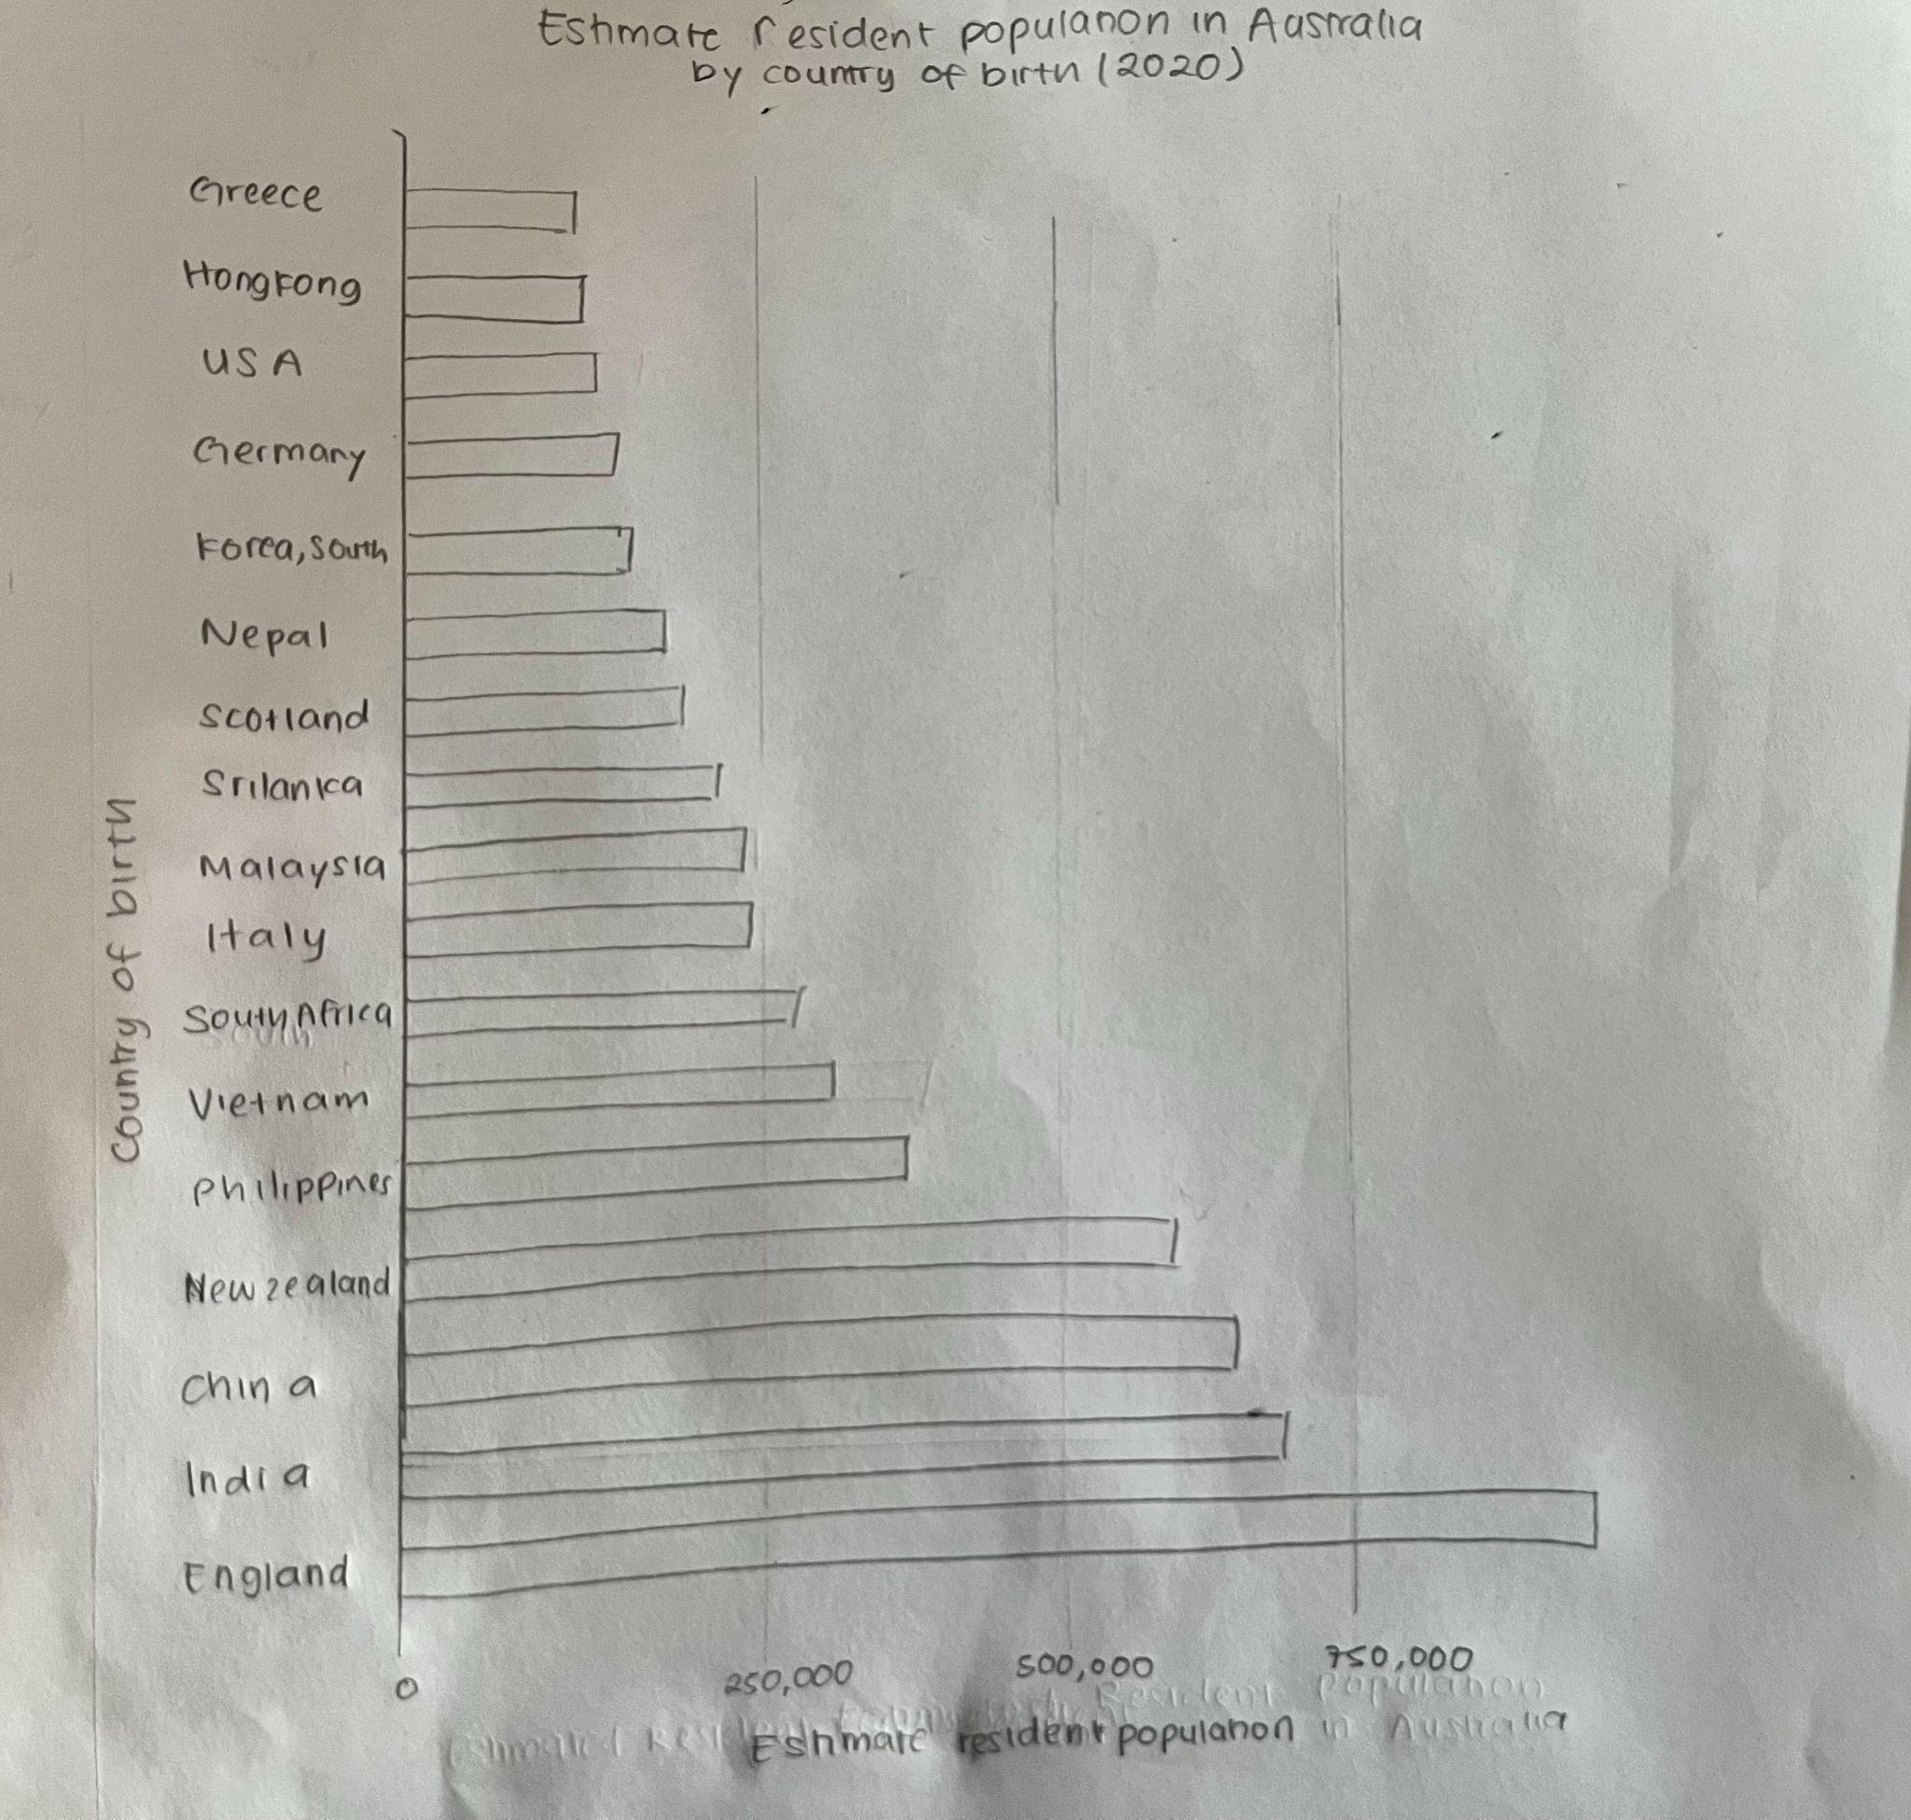

**Figure<>: Estimated resident population in Australia(first iteration)**

**Description:**

|  |  |
| --- | --- |
| Advantages | Disadvantages |
| Horizontal bar graphs have the benefit of being easily comprehended since they provide a clear visual representation of the data, making it simple for users to discover which country migrates the most to Australia and compare the estimated resident population of different countries in Australia. | In terms of visual presentation, including over ten countries in a horizontal bar chart causes the chart to become overcrowded, making it difficult for users to read and comprehend the data displayed in the horizontal bar graph. |
| The horizontal bar chart illustrates the relative size of the migrant population in each country with respect to the others. It is helpful in determining which countries are the primary sources of migration. |  |

* 1. 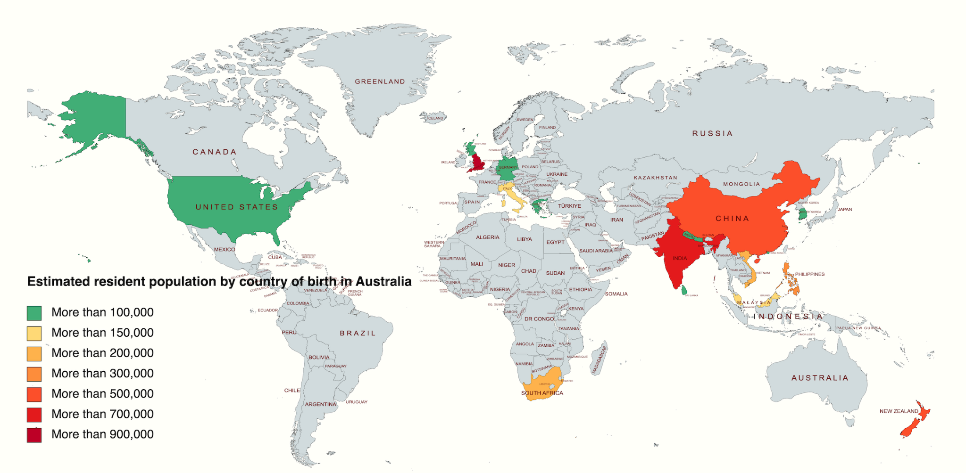**Option 2: Heat wave map chart**

### 

|  |  |
| --- | --- |
| Advantages | Disadvantages |
| A heat wave map chart may be effective in illustrating the estimated migrant population in Australia across various geographic regions based on its colour intensity. | The heatwave map graphic employs colour gradients to illustrate the estimated population by country of birth, which may reduce details and complexity. |
| A heat wave map chart displays data overlaid on a geographical map to enable viewers to visualise how the migrant population in Australia is distributed geographically according to their country of origin. | Colour choices in heatwave maps may influence how users interpret the estimated number of migrants in Australia, contributing to bias and misleading information. |
| Heatwave maps provide a visual comparison of migration patterns and trends across different locations in Australia by using a variety of colours. It is possible to identify quickly which countries of origin have the largest number of migrants. As a result, users can gain insight into the country from which most migrants originate. | The heatwave map chart does not give the users an extensive amount of interaction because it simply illustrates the overall pattern of the migrant population in Australia. The users have no direct access to the data. |
| A heatwave map can effectively manage large datasets, as it provides a concise representation of the data. |  |

### **4.1.2 Visualisation 2: The internal migration of different states in Australia**

### **Option 1: Horizontal Bar Graph**

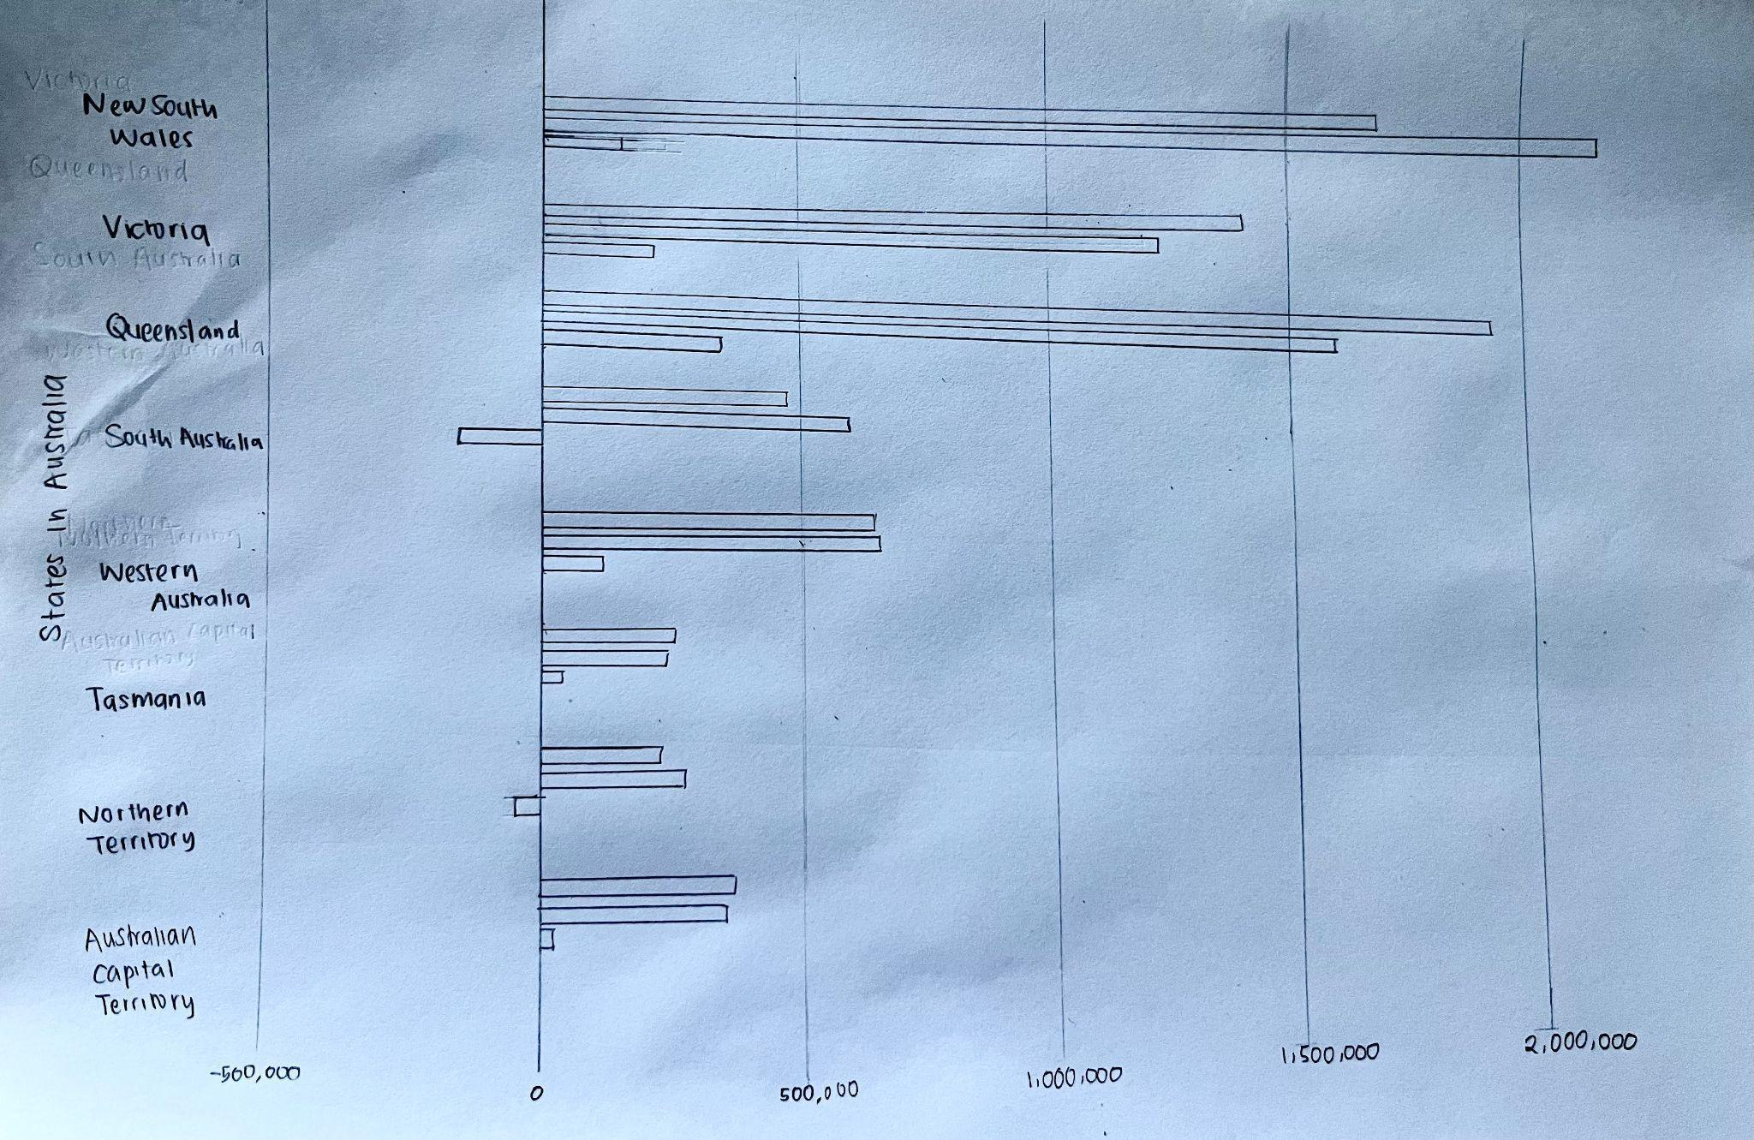

|  |  |
| --- | --- |
| Advantages | Disadvantages |
| It allows for a relatively simple visual comparison of states. The lengths of the bars directly indicate the values of net internal migration, total estimations of arrivals and departures, making users easily discover which states have the highest number of internal migrations. | The chart may cause visual disorientation since it represents many variables such as total estimated arrivals, total estimated departures, and net internal migration for each of Australia's states. This makes it challenging for the user to appropriately identify and compare multiple variables. |
| A horizontal bar chart can be beneficial for showing and condensing enormous data sets in an organised and easy-to-understand manner. Each state can be represented by only one bar, providing an in-depth understanding of migration trends in Australia. | A horizontal bar chart lacks geographical information; hence it may not directly represent the geographical spread of internal migration among Australia's states. Users may need to depend on their prior knowledge of the states' locations or look to a different map to have a clearer idea of the geographic aspect. |
| The horizontal arrangement of the bars makes the magnitudes of migration across states simpler to observe and compare, allowing for a rapid evaluation of which states have the most internal movement. |  |

1. 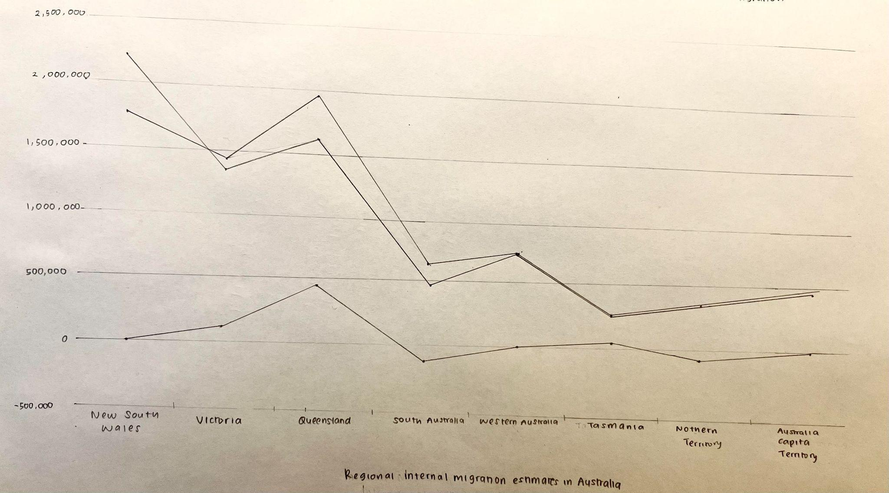**Option 2: Line graph**

|  |  |
| --- | --- |
| Advantages | Disadvantages |
| As a line graph employs plotted dots to indicate the values of each variable in each state, users may clearly determine changes in total estimated arrivals, total estimated departures, and net internal migration for each state. | Line graphs can become complex and difficult to understand when multiple variables are being displayed simultaneously, such as net internal migration, total arrivals, and departures. The visualisation may be further complicated if different scales or units of measurement are used for each variable. |
| The line chart efficiently communicates numerical data concerning net internal migration. Users may easily comprehend the differences between states in terms of net internal migration by using line charts with labelled data points. |  |
| Line charts allow users to compare internal migration patterns between states. By placing multiple lines on a graph, users can quickly determine which states have experienced higher or lower levels of internal migration and how they compare to each other. |  |

1. **Option 3: Stacked bar chart**

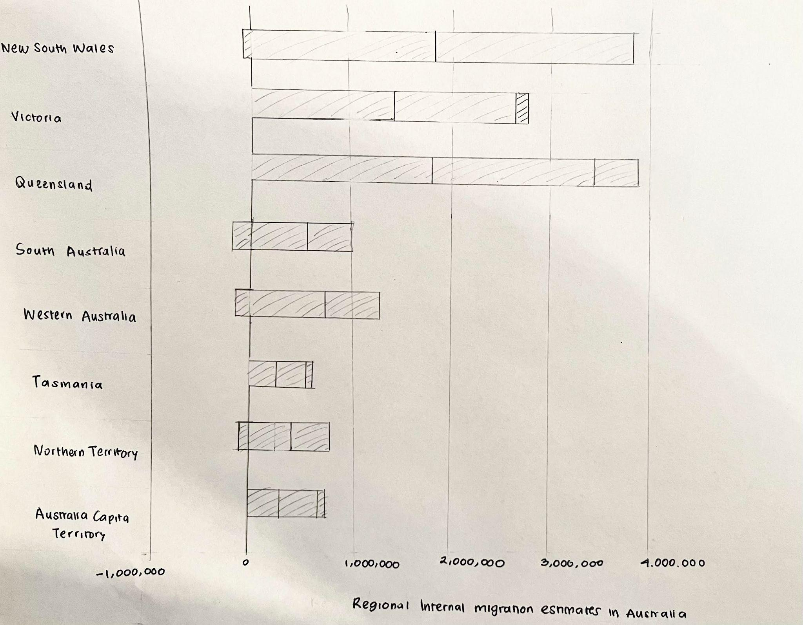

### 

### 

### 

### 

### 

### 

### 

### 

### 

### 

### 

### 

|  |  |
| --- | --- |
| Advantages | Disadvantages |
| Horizontal stacked bar charts allow users to easily compare the magnitude of the total estimate arrivals, total estimate departure and net internal migration. Users can easily distinguish which states in Australia have larger and smaller values for each of the attributes represented in the chart and make comparisons across Australia states. | There is a risk that the stacked bar charts will become congested due to the large number of states that must be represented in the chart, making the visualisation overwhelming for website visitors. |
|  | Establishing detailed comparisons between individual values within each segment of a stacked horizontal bar chart is difficult for users. The length and height of the bars might cause visual distortions, making identifying the accurate exact values difficult. |

### **4.1.3 Visualisation 3: Types of visas used by migrants to migrate to Australia**

1. **Option 1: Pie chart**

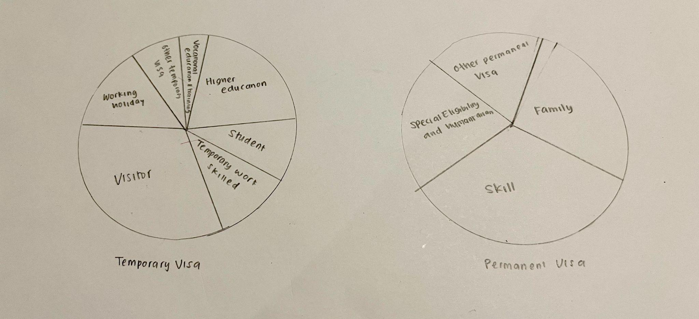

The pie chart allows users to compare the NOM arrivals numbers in different visa categories. Each visa type will be depicted as a slice, with the angle size representing the relative values of NOM arrivals for the visa types utilised by migrants in Australia. The greater the NOM arrivals values, the larger the angle size of the slice. Pie charts can assist users in determining which sort of visa is most used by migrants to come to Australia. This is determined by seeing which visa categories have the largest angle size. Different Hue colours can be used to differentiate the visa types. The type of visa utilised by migrants can assist in determining the migrants' intentions for coming to Australia. For example, when a migrant uses a working visa, it may be assumed that migrants come to Australia because there are greater job prospects.

|  |  |
| --- | --- |
| Advantages | Disadvantages |
| The use of pie charts facilitates straightforward comparison of different types of visas or key groupings. Each slice can be examined visually to determine which groups or visas have a higher or lower percentage or values of net overseas migration which provide an easy way for use to compare the different visa categories. | It is difficult for users to read the pie chart that has the same size of slice or any slice that has small angles which leads to users having a challenge on how to differentiate between them. Users will have difficulty comparing different groups and visas that have low numbers of net overseas migration arrivals or visas that have similar values of net overseas migration arrivals. |
| The pie chart illustrates the different values of net overseas migration arrivals in each visa category by using different angle slices, allowing users to easily identify which groups or types of visas are the most dominant within the chart and providing a clear visualisation of the net overseas migration arrivals values. | Since a pie chart only provides an overview of percentages, users will have difficulties precisely comparing the specific values of net overseas migration arrival in each visa category. |
|  | Pie charts are not suitable to compare numerous categories and the slice can become visually cluttered and this leads the user to have difficulty reading the values in each slice. |

1. **Option 3: Donut chart**

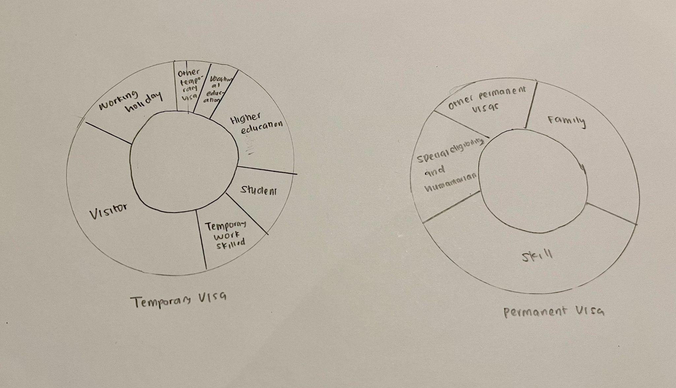

The doughnut chart allows users to compare the NOM arrivals numbers in different visa categories. Each visa type will be depicted as an arc, with the length of the arc representing the relative values of NOM arrivals for the visa types utilised by migrants in Australia. The greater the NOM arrivals values, the longer the length of the arc. Doughnut charts can assist users in determining which sort of visa is most used by migrants to come to Australia. The type of visa utilised by migrants can assist in determining the migrants' intentions for coming to Australia. For example, when a migrant uses a working visa, it may be assumed that migrants come to Australia because there are greater job prospects.

|  |  |
| --- | --- |
| Advantages | Disadvantages |
| As the donut chart uses different lengths of arcs to represent different values of NOM arrivals, users can focus more on the length rather than the slice angle, area, and size. This can also help users easily observe and understand the message conveyed by the donut chart. | There is a potential that users will have a hard time reading the differences in the NOM arrivals values between different sections (Visa categories) of the donut chart. |
| Donut charts can be used to compare datasets. Two donut charts can be placed next to each, and the middle hole of the donut chart can be used to show the donut chart is compared.  Alternatively, a donut chart can be used for more than 2 datasets in one donut chart which will become a stacked donut chart. | The Donut chart is only suitable for a limited number of categories (2-5 categories). |
| Doughnut charts are also more space efficient than pie charts since the blank centre may display more information. |  |

1. **Option 3: Bar chart**

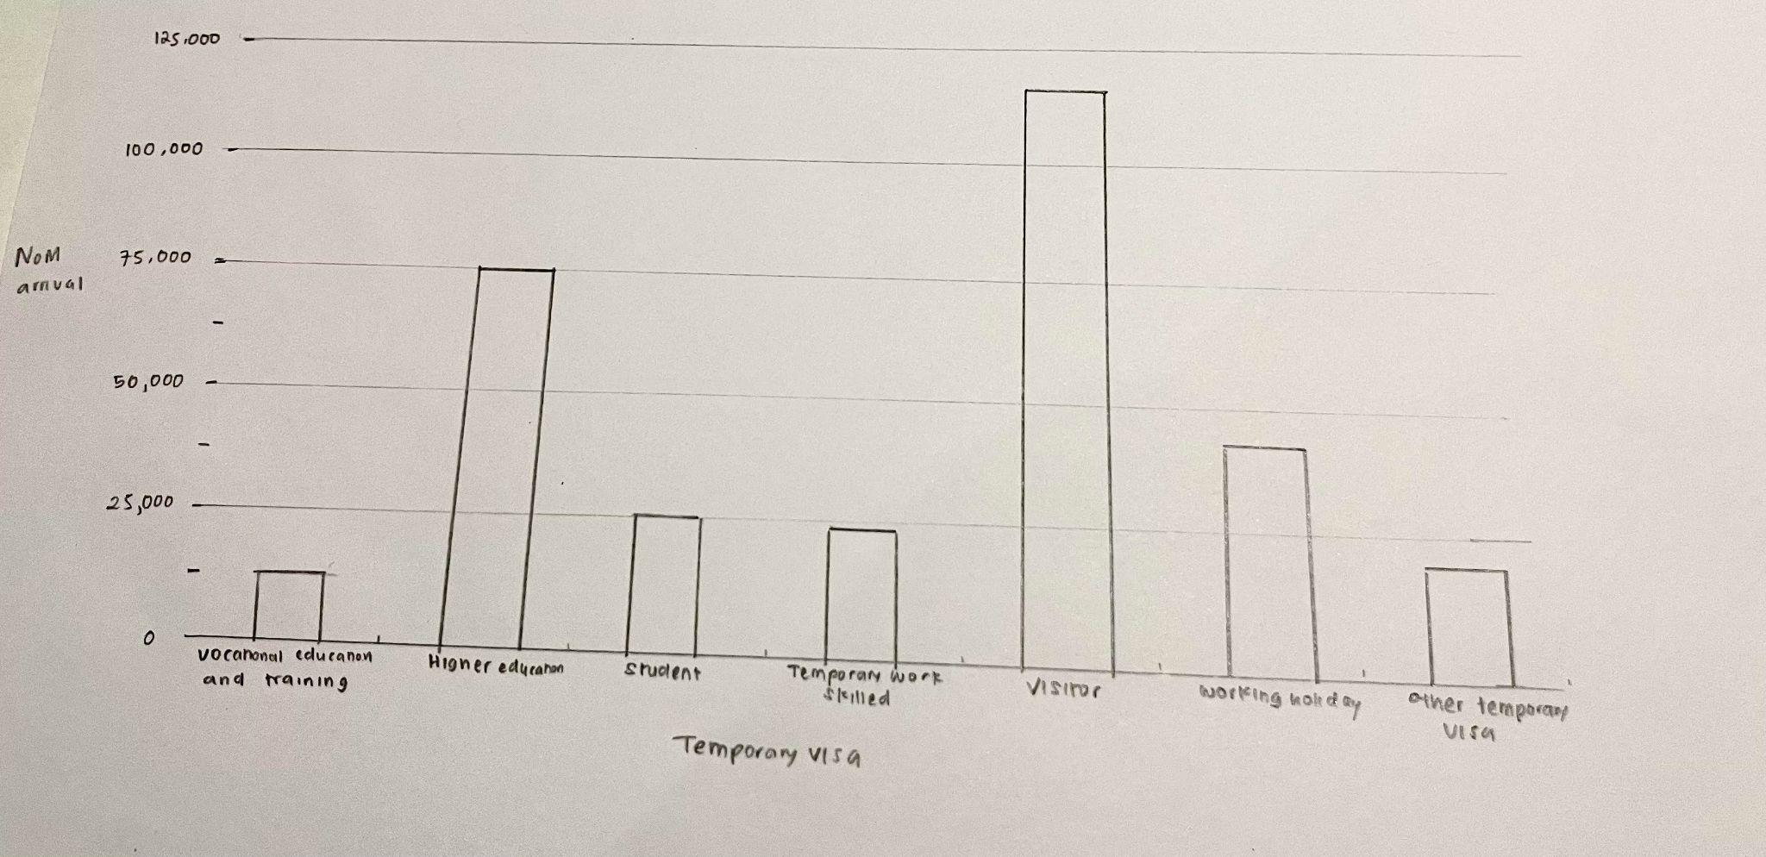

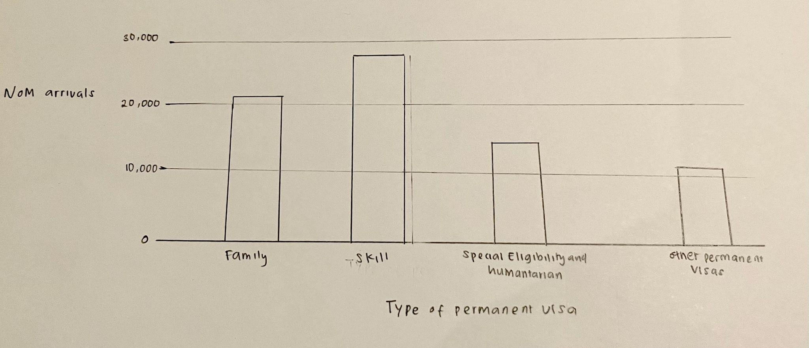

## 

## 

## 

## 

## 

## 

|  |  |
| --- | --- |
| Advantages | Disadvantages |
| The bar chart depicts the relative values of NOM arrivals for each visa category in an easy-to-understand visual manner. | Two bar charts need to be used to compare temporary visa and permanent visa. |
| The bar chart displays the accurate value of the net overseas migration arrivals in the Y-axis. Different lengths of bars are used to express different values of net overseas arrivals in each visa categories. | Bar chart is only effective to compare small number of categories. |
| By using a bar chart, user need little amount of explanation as the data that want to be conveyed by the visualisation is all available in the chart and most users have known on how to analyse a bar chart. |  |

## 

## 

## 

## 

## **4.2 Visualisation Design (Progress)**

* Make sure to give reason why the graph is chosen instead of the graph in the proposal

**4.2.1 Visualisation 1: Estimated Resident Population in Australia by Country of birth**

1. **Heatwave map chart**



### 

### **4.2.2 Visualisation 2: The internal migration of different states in Australia**

The second iterations are listed below:

1. Option 1: Horizontal bar graph

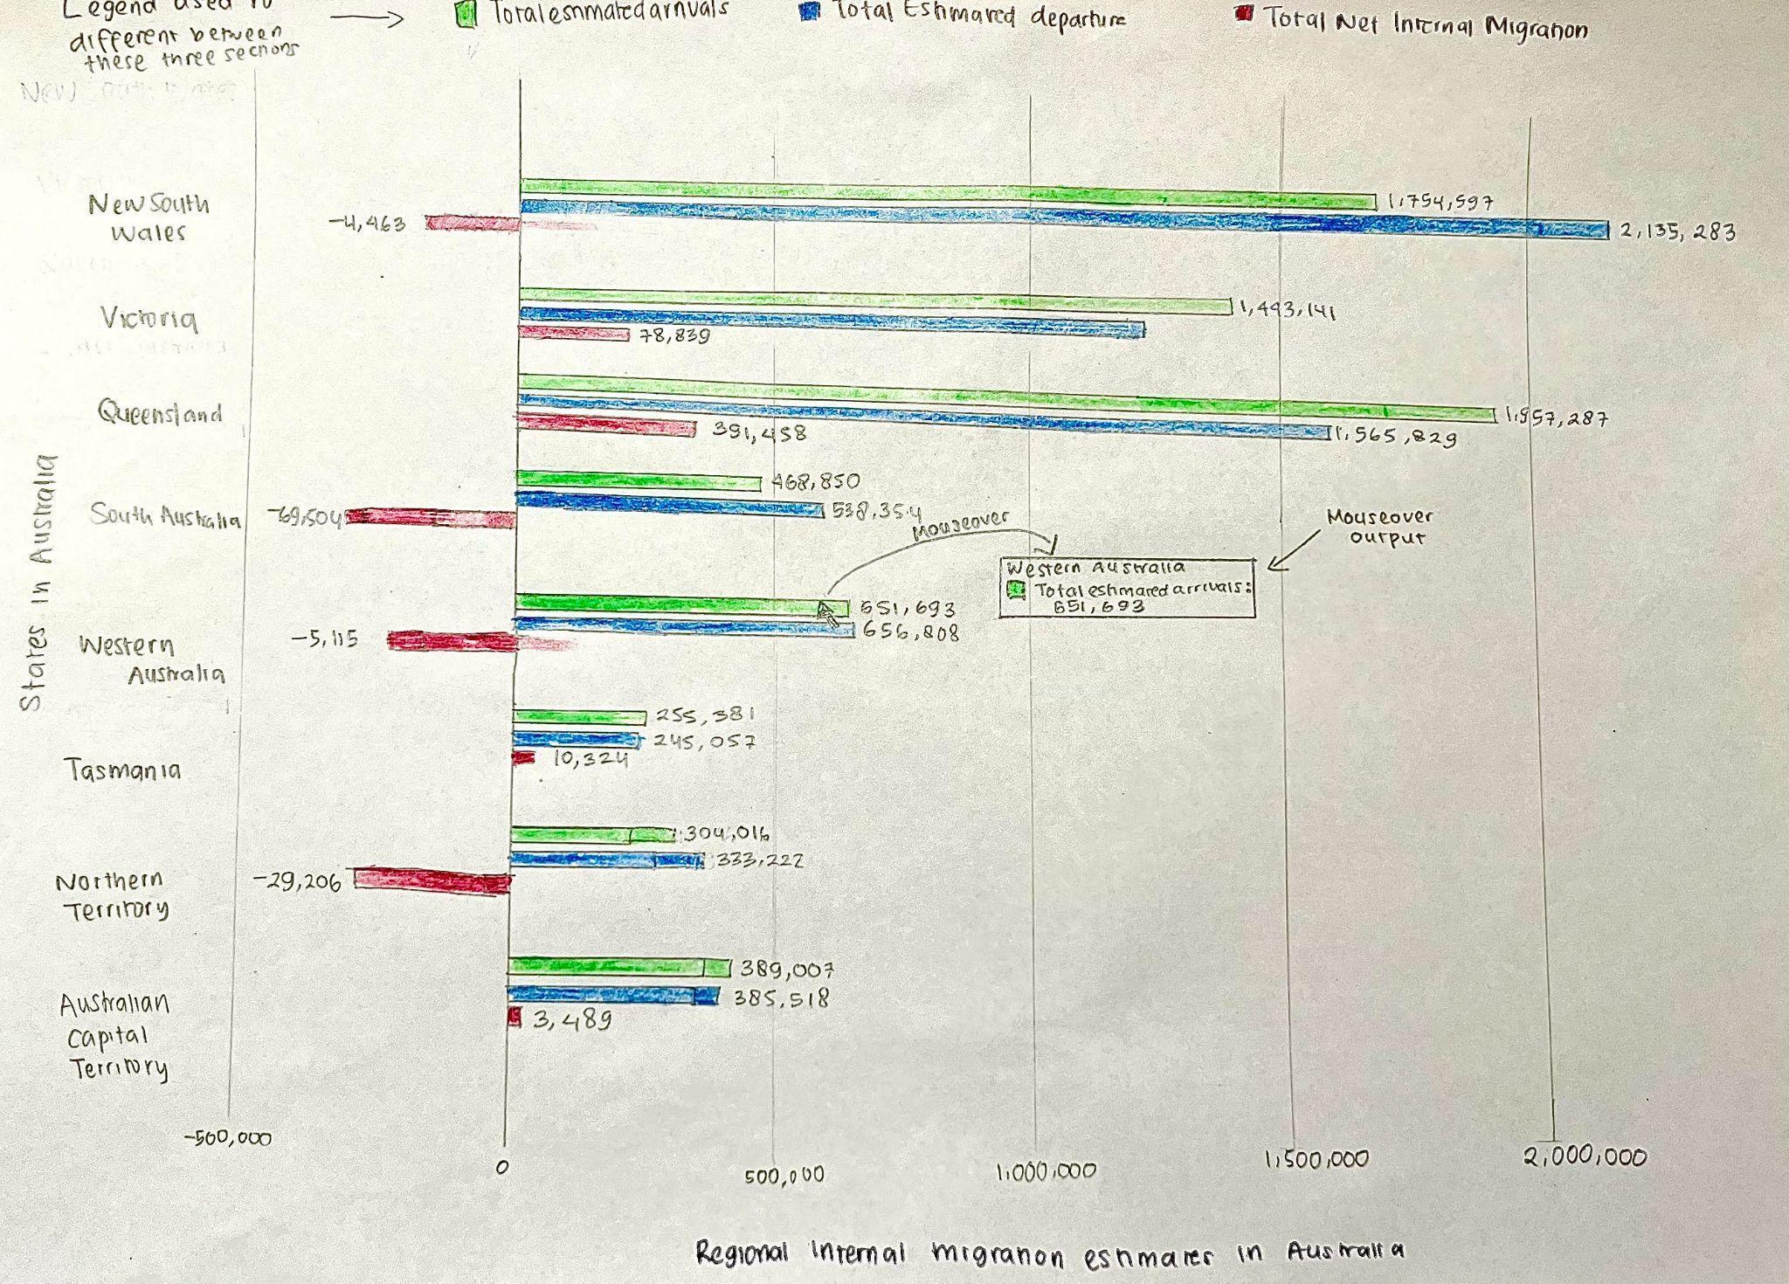

* Three distinct hue colours are used to symbolise total expected arrivals, total estimated departures, and total net internal migration.
* The values of total estimated arrivals, total estimated departures, and total net migrations are labelled besides the bars. The labels assist users in determining the actual values of the data points shown, making the graph more informative and precise.Readers may accurately compare which states have the most estimated arrivals, estimated departures, and net internal migration, and this allows users to precisely conclude which states have the most estimated arrivals, estimated departures, and net internal migration.
* In the horizontal bar graph above, legends are utilised at the top to assist viewers understand which colour represents total estimated arrivals, total estimated departures, and total net migrations.
* Titles are provided beneath the horizontal bar graph to help the user comprehend the context of the horizontal bar graph.
* The data contained inside the horizontal bar graph are all related to internal migration and adhere to the Tufte Integrity Principles.
* The horizontal bar graph shown in Figure has two sides. These two sides aid in conveying the negative and positive figures of total net migration in each Australian state. The left side of the horizontal bar graph shows negative total net migration values, whereas the right side represents positive total net migration values.
* Different bar widths are used to visually compare the magnitude of the numbers being represented, allowing users to notice the difference in values across different bars.

1. Option 2: Line graph

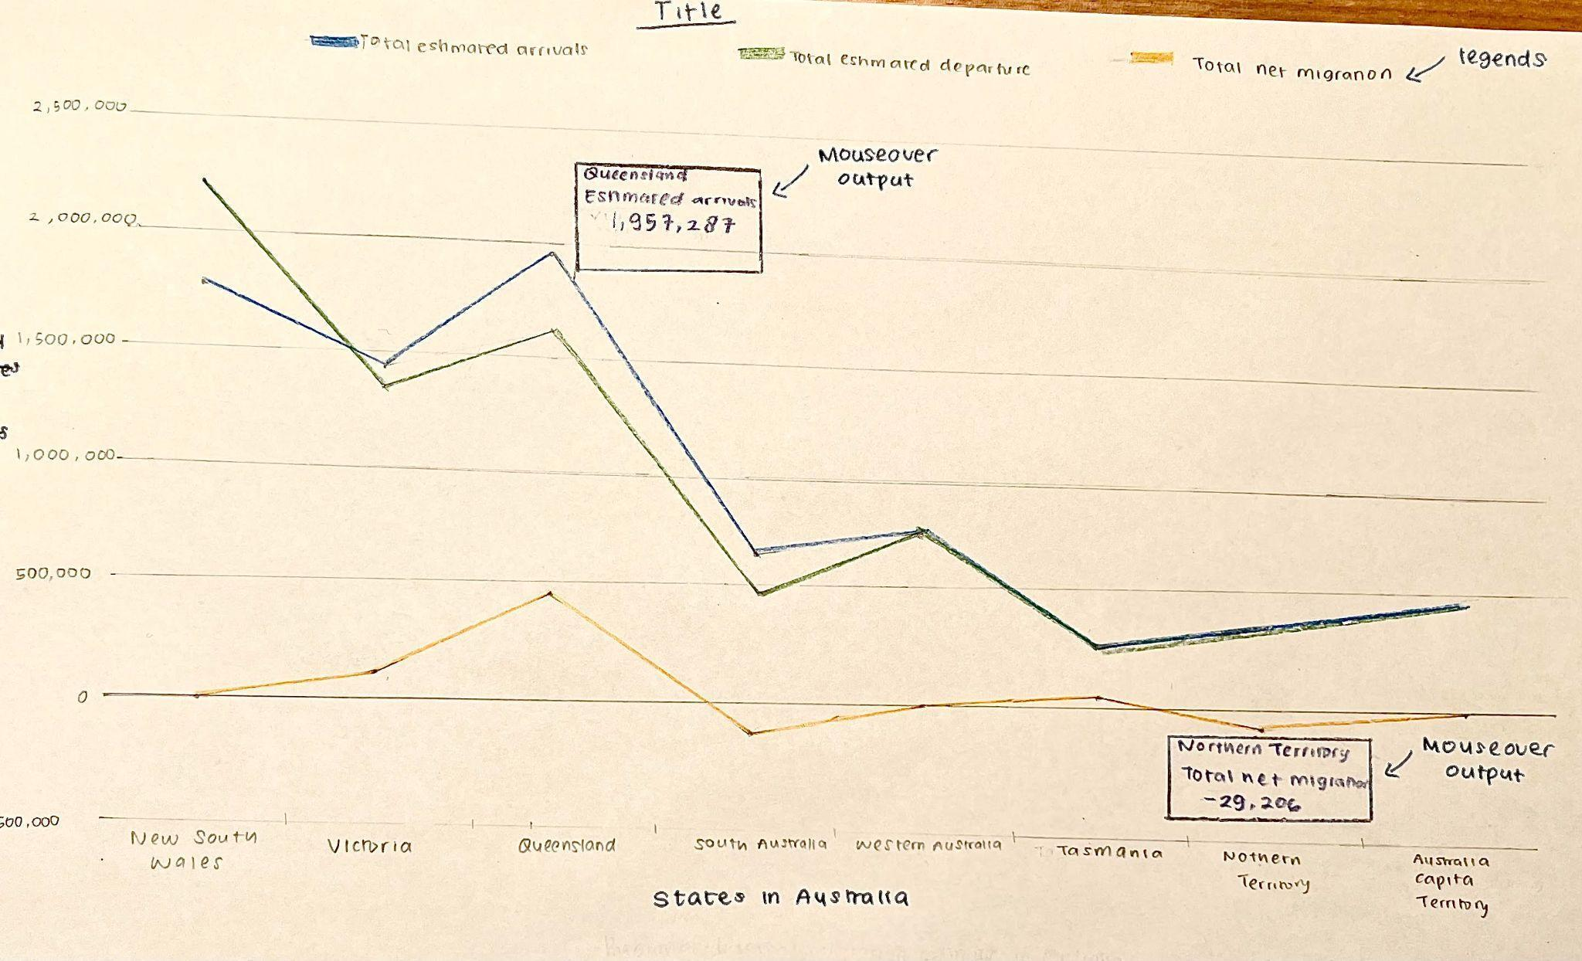

* Titles are provided above the graph to help the user comprehend the context of the horizontal bar graph.
* Each of the X and Y axes are labelled according to the values that they are representing. The X axis in the line graph shown in Figure are labelled as states in Australia while the Y axis are labelled as <>.
* The line graph starts from 0 which follows the Tufte integrity principles of <>(In text citation).
* Three distinct hue colours to symbolise total expected arrivals, total estimated departures, and total net internal migration in the line graph.
* The data contained inside the line graph are all related to internal migration and adhere to the Tufte Integrity Principles of (in text citations).
* Two sides of line graphs are used in Figure<>. These two sides aid in conveying the negative and positive figures of total net migration in each Australian state. The top side of the line graph shows positive total net migration values, whereas the bottom side represents negative total net migration values.
* In the line graph above, legends are utilised at the top of the graph to assist viewers understand which colour represents total estimated arrivals, total estimated departures, and total net migration.

### **4.2.3 Visualisation 3 : Types of visa used by migrants to migrate to Australia**

1. Option 1: Pie chart

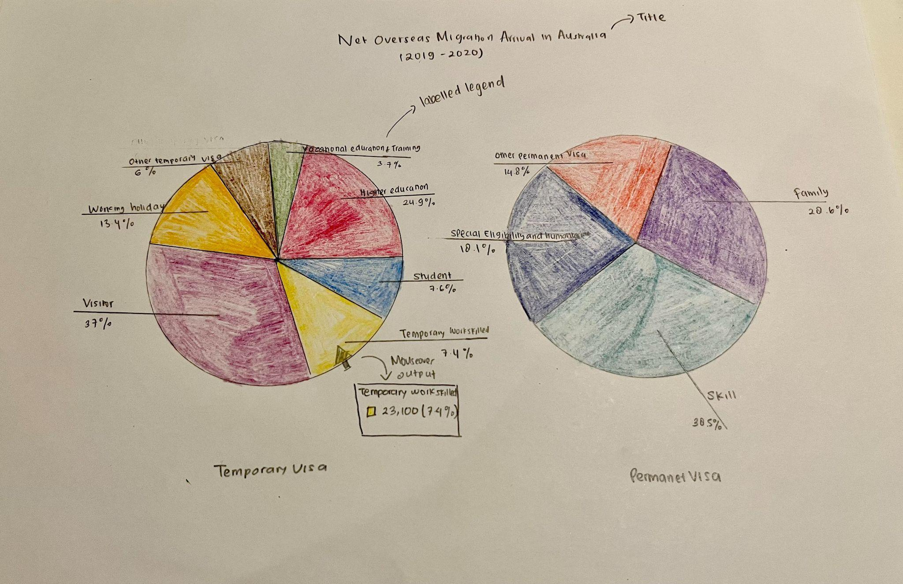

* 7 hues colours are utilised in the temporary pie chart to represent 7 types of temporary visas. 4 hues colours are used in the permanent visa pie chart to represent 4 types of permanent visas. By using different hues, users can easily identify each pie slice and understand what each slice represents.
* Labelled legends are used both in Temporary Visas and Permanent visas pie charts. Labelled legends are used to help users to identify what categories are represented in each pie chart slice and it allows users to quickly differentiate what each pie slice is representing. Labelled legends are also used to show users more detailed information about what each pie slice represents such as the values of net overseas migration of a particular type of visa.
* Titles are provided above the graph to help the user comprehend the context of the pie chart.
* Different size of pie slices are used in both temporary and permanent visa pie chart in which this

1. Option 2 : Donut chart

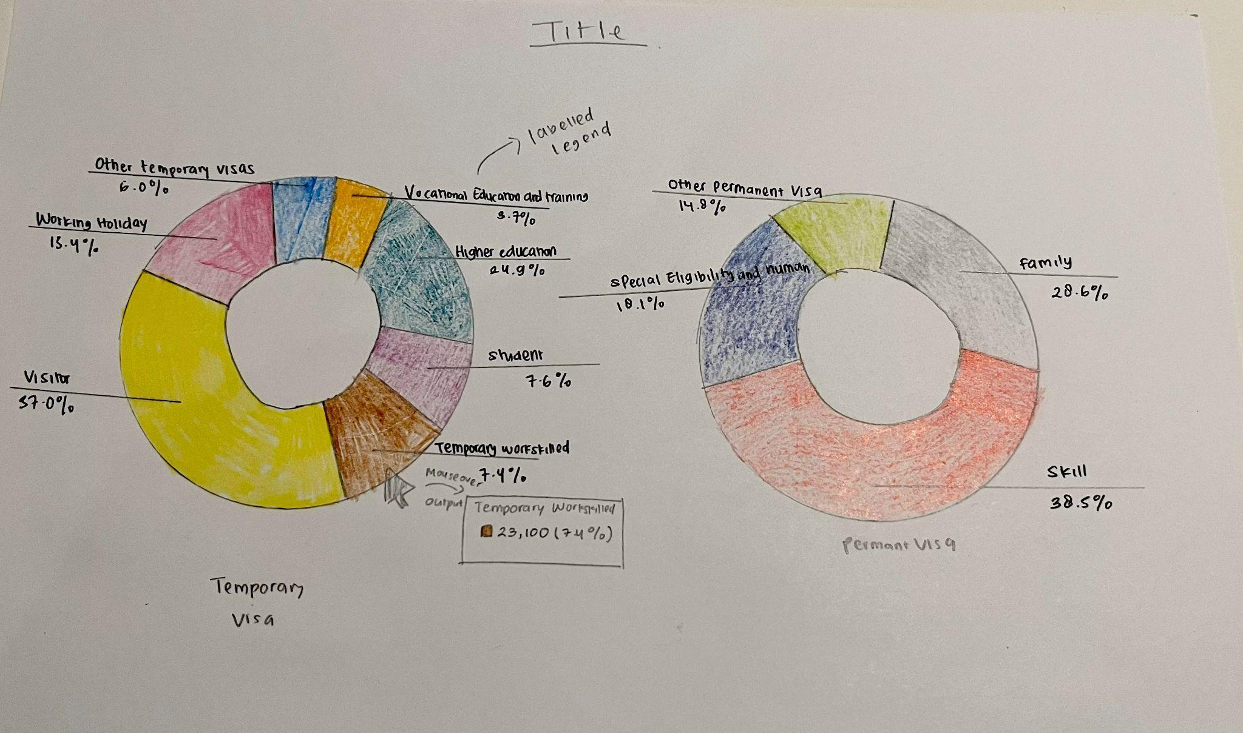

* 7 hues colours are utilised in the temporary donut chart to represent 7 types of temporary visas. 4 hues colours are used in the permanent visa donut chart to represent 4 types of permanent visas.By using different hues, users can easily identify each pie slice and understand what each slice represents.
* Labelled legends are used both in Temporary Visas and Permanent visas donut charts. Labelled legends are used to help users to identify what categories are represented in each pie chart slice and it allows users to quickly differentiate what each pie slice is representing. Labelled legends are also used to show users more detailed information about what each pie slice represents such as the values of net overseas migration of a particular type of visa.
* Titles are provided above the graph to help the user comprehend the context of the donut chart.

1. Option 3: Bar chart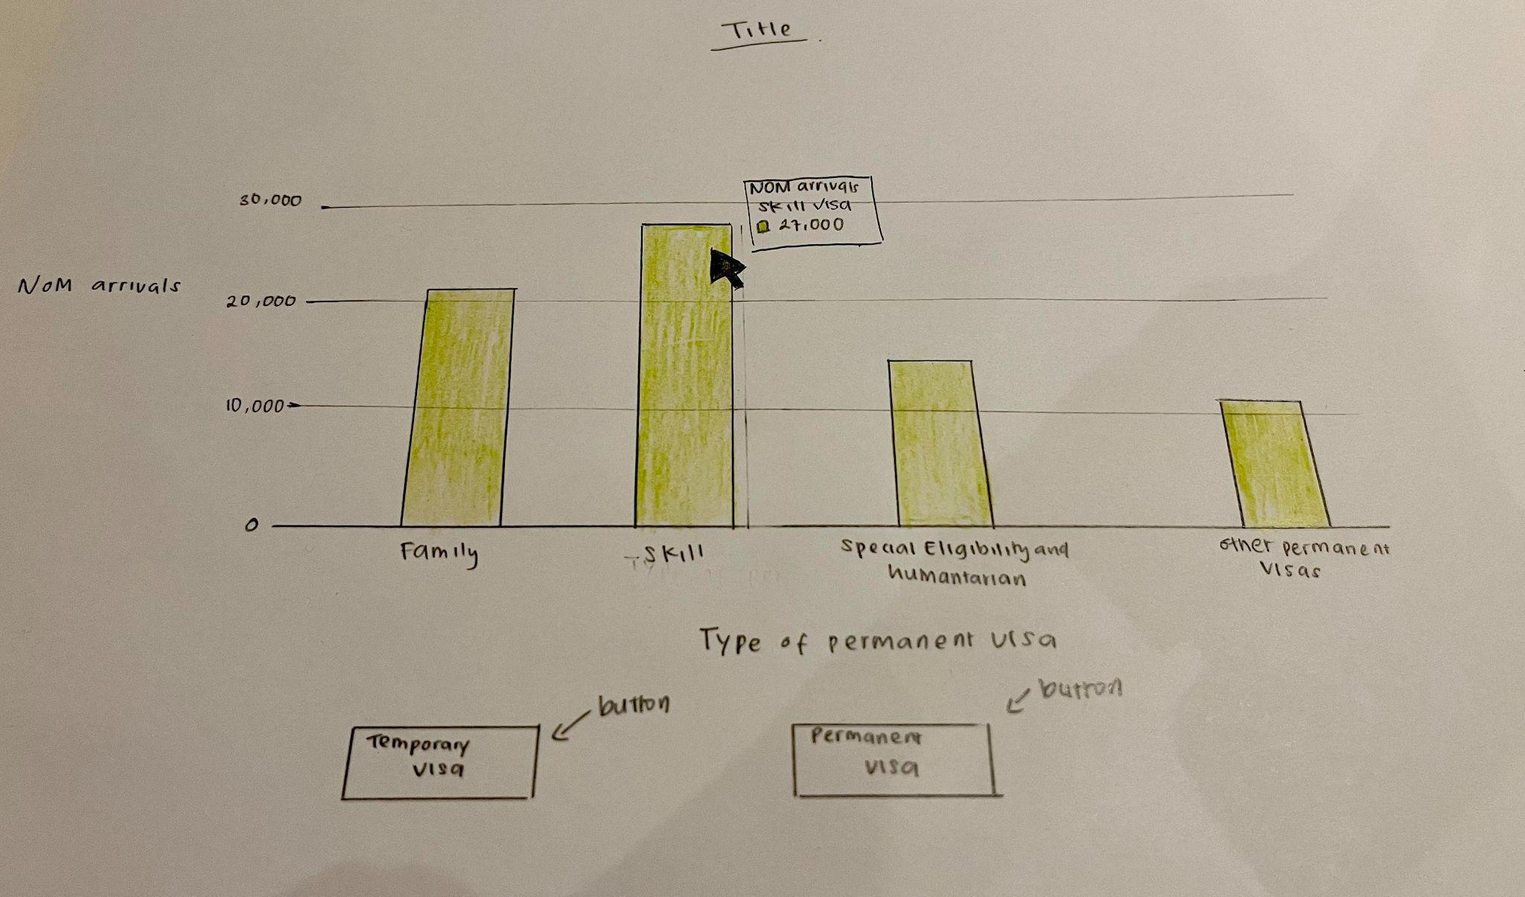

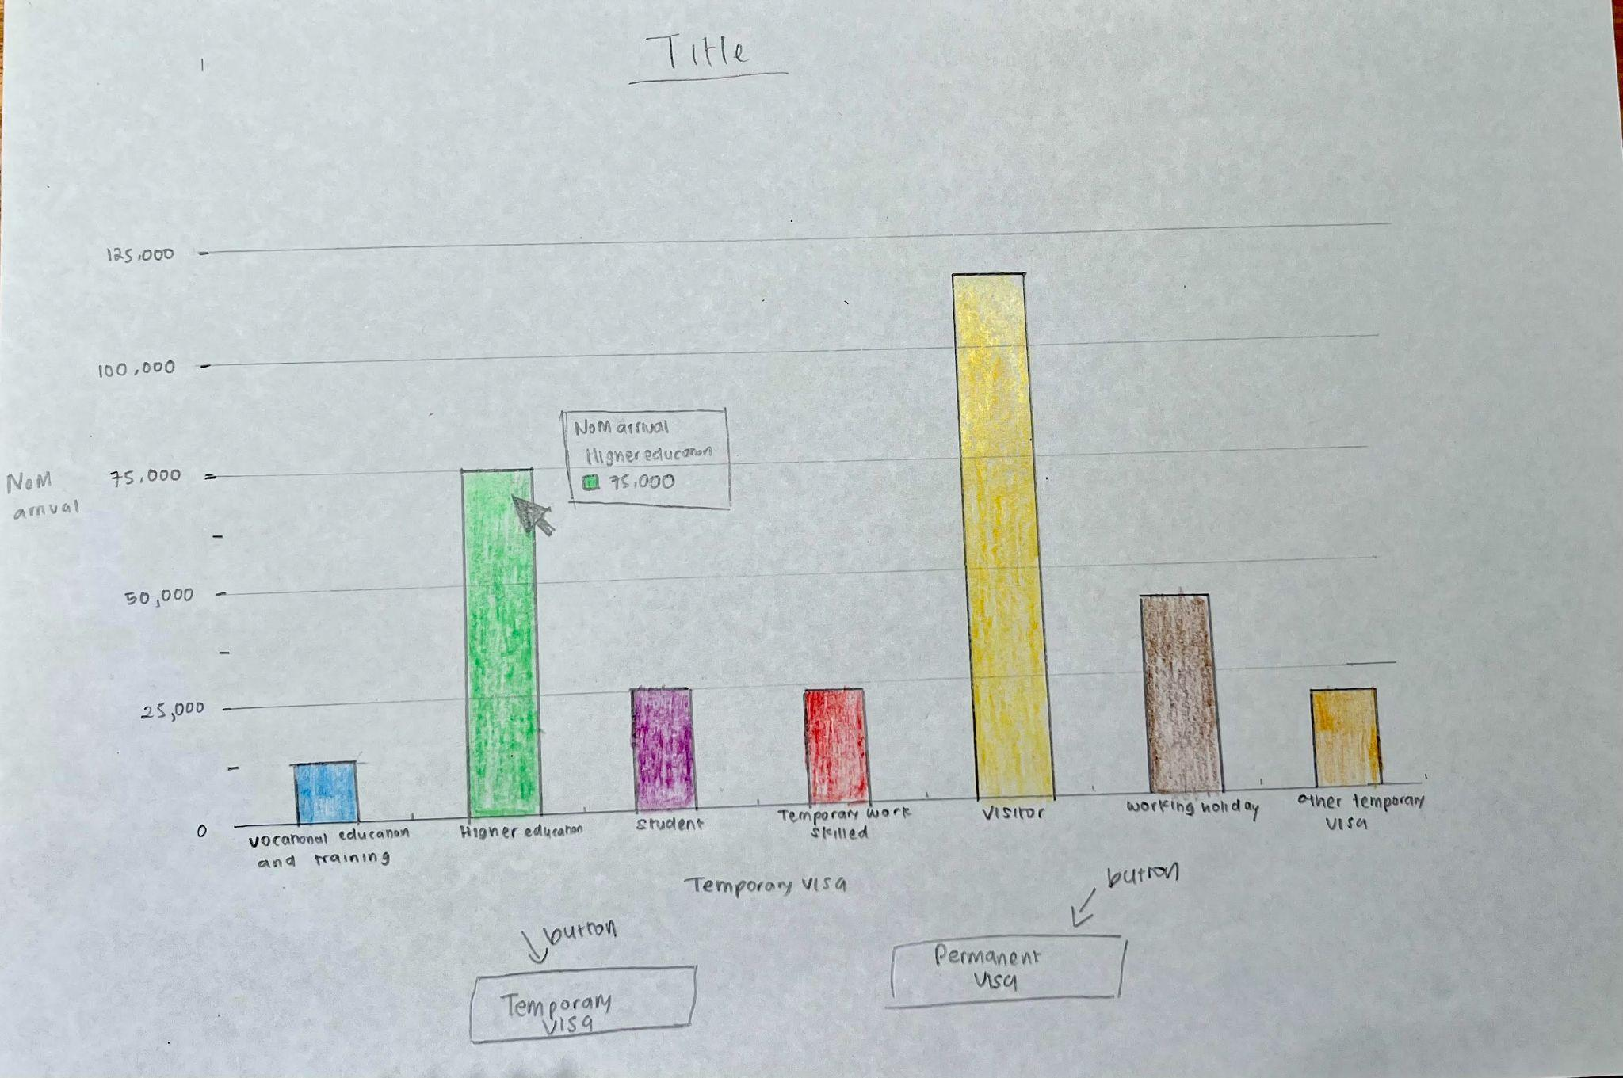

* Titles are provided above the graph to help the user comprehend the context of the bar graph.
* Buttons are used to allow users to see each of the temporary and permanent visa bar chart visualisation.

## **4.3 Visualisation Design(Final)**

Final sketches that is used in the website

## **4.3.1 Visualisation 1 : Estimated Resident Population in Australia by country of birth**

### **4.3.2 Visualisation 2 : The internal migration of different states in Australia**

### **4.3.3 Visualisation 3 : Types of visa used by migrants to migrate to Australia**

# **Validation**

# **Conclusion**

# **References**

* Amruta, P. 2023, *Types of migration - geography notes - prepp*, *Types of Migration-Geography Notes-Prepp*. Prepp by College Dunia.,viewed 7 April 2023, <https://prepp.in/news/e-492-types-of-migration-geography-notes>
* Central Intelligence Agency (no date) *Country Comparisons-Net Migration Rate*, *Central Intelligence Agency*. Central Intelligence Agency. Available at: https://www.cia.gov/the-world-factbook/field/net-migration-rate/country-comparison (Accessed: April 26, 2023).
* Kiwimedi support (2022) *Birth tourism: Advantages of giving birth in a foreign country - kiwimedi blog*, *KiwiMedi*. Available at: https://www.kiwimedi.com/birth-tourism/ (Accessed: April 10, 2023).